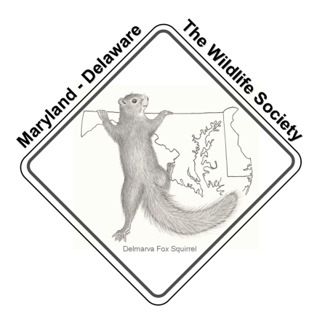
Maryland/Delaware Chapter – The Wildlife Society
Fall Meeting
October 3, 2025
Seneca Creek State Park
11950 Clopper Rd, Gaithersburg, MD 20878

Agenda

9:00 am: Registration, Coffee and snacks provided, Yard sale goes live
9:30 am: Joshua Tabora - Call to Order, Introductions, & Chapter Announcements, Treasurer's report
9:45 am: Risharda Harley - Accokeek Foundation Forest Management
10:20 am: Kaitie Kessler - Allegheny Woodrat Captive Breeding at the Maryland Zoo
10:45 am: Break, Posters
11:00 am: Ryan Colliton - Building a Prescribed Fire Program in Montgomery County
11:30 am: Amanda Weschler - Maryland Marine Mammal and Sea Turtle Stranding Response Program
12:00 pm: Catered Lunch
1:00 pm: Team Trivia
1:30 pm: Officer Elections, Awards, Poster Presentations
2:00 pm: Yard sale winners announced
2:30 pm: Closing remarks, Adjourn

